**WEEK 8 HANDS ON**

Thipi Reddy Siddikeshwer Reddy(6412551)

**GIT**

**Exercise 1: Basic Git Setup and Adding Files to a Repository**

Code:

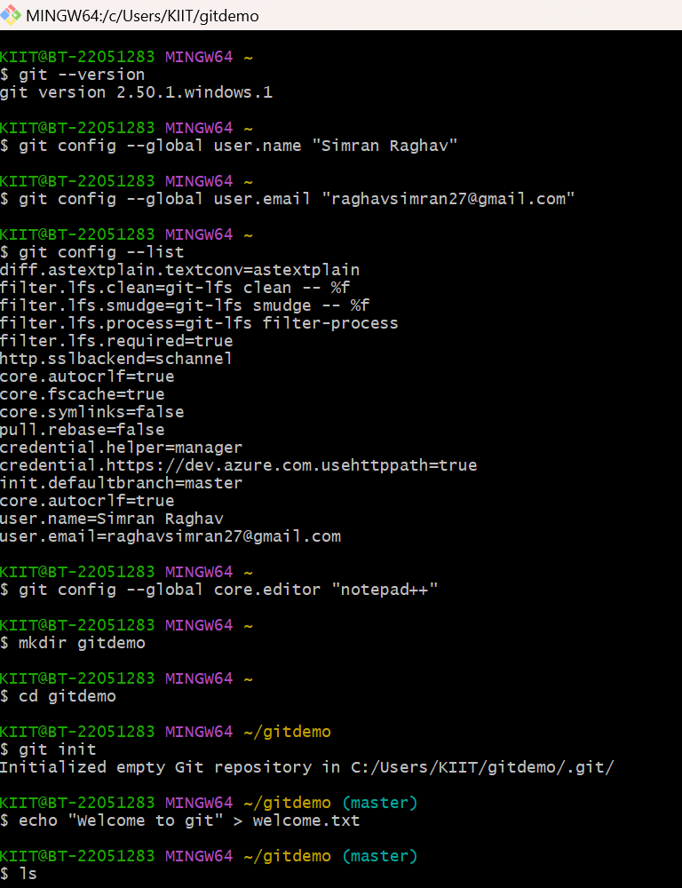

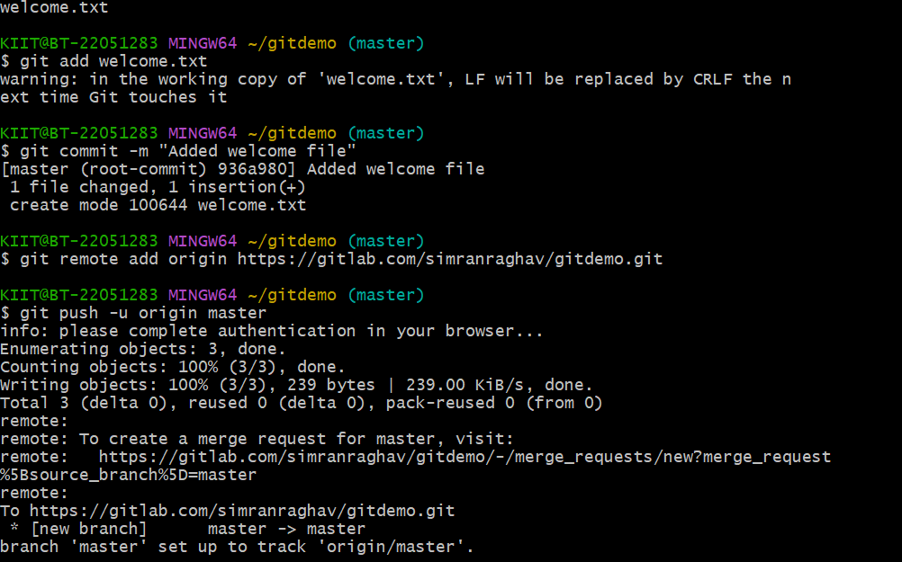

**Exercise 2: Ignoring Unwanted Files Using .gitignore**

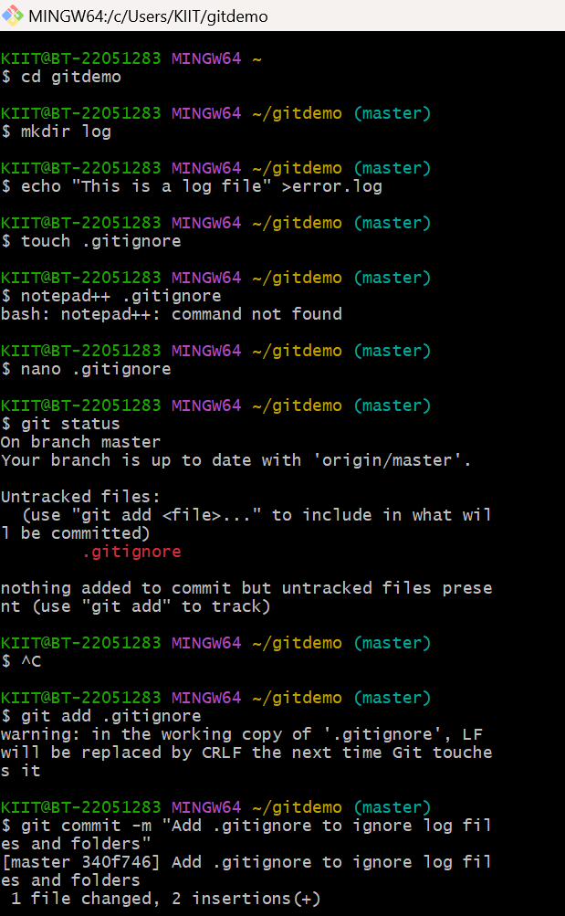

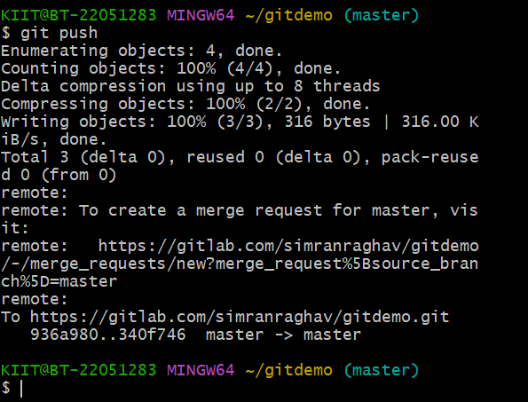

**Exercise 3: Branching & Merging**

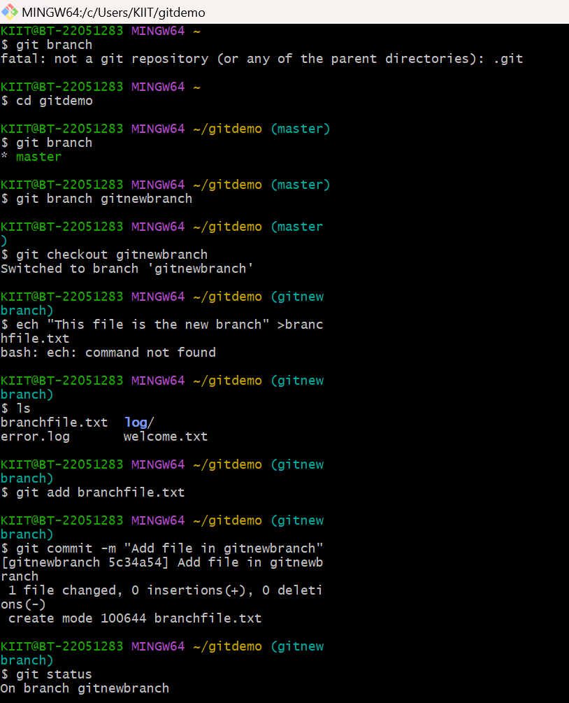

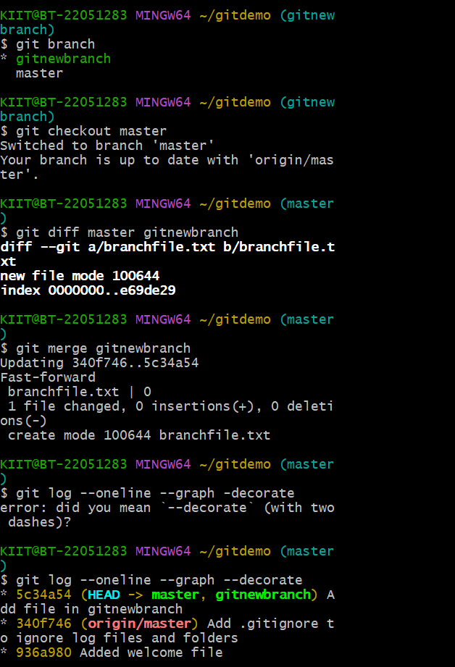

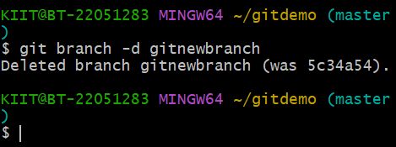

**Exercise 4:Conflict Resolution**

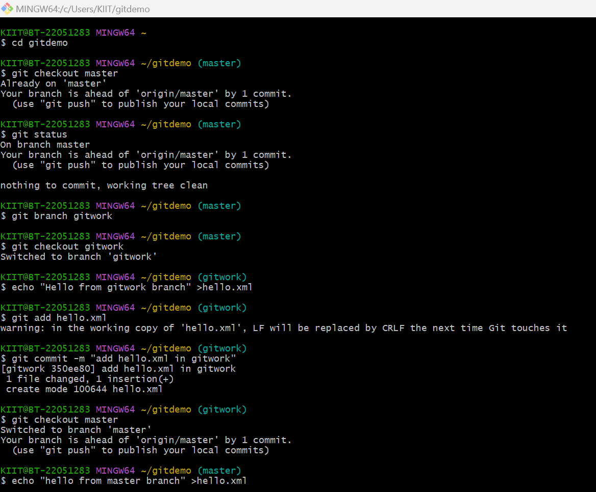

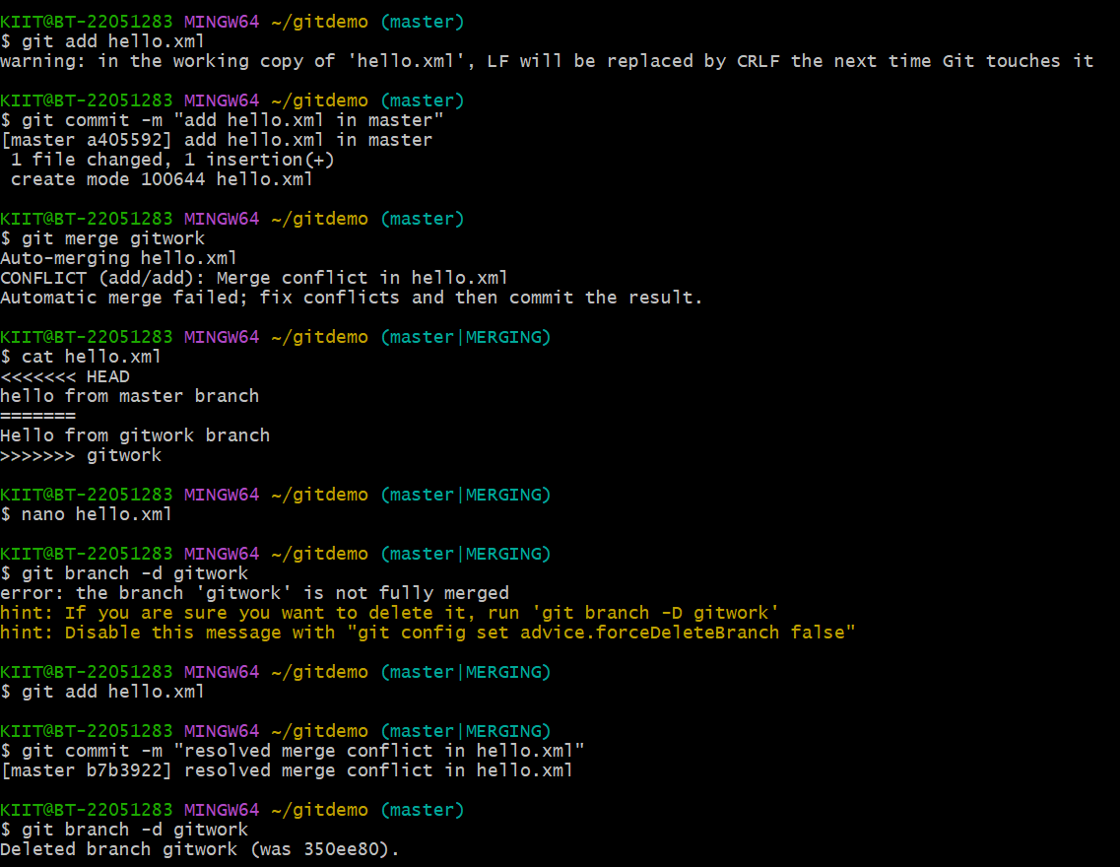

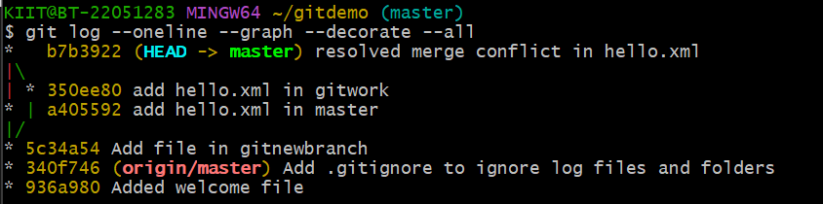

**Exercise 5:Cleanup and pushing to remote**

